Practical 6: Stack Implementation using Array and Linked List, with Expression Processing
Problem 1
A cafeteria stacks clean trays on a fixed-size counter. New trays are always placed on top, and customers always take from the top. The counter can hold at most n trays at a time — if it is full, no more trays can be added, and if it is empty, no tray can be taken. Given a sequence of place and take operations, implement this fixed-capacity tray stack and print the current top tray after each operation. Report an error if a place or take operation cannot be performed.
Describe how your solution tracks whether the stack is full or empty. What are the exact conditions you check before a push and before a pop, and what does your program do when those conditions fail?
Code
https://github.com/AD-9218/DATA-STRUCUTURE-AND-ALGORITHM/blob/main/Practical-6/6_1.cpp
Output
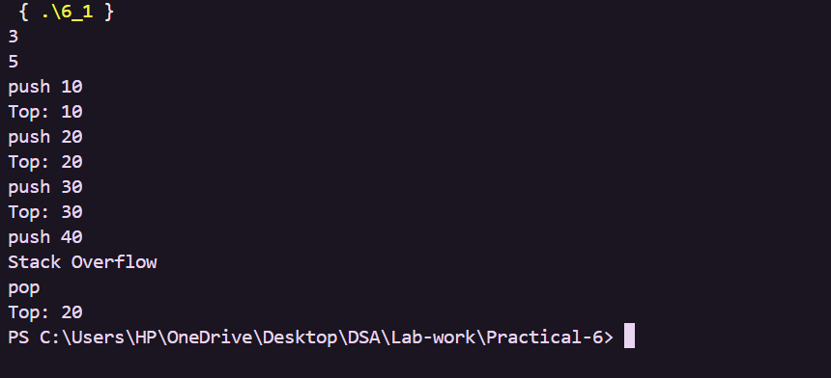
Problem 2
A web browser keeps track of pages visited so that the back button always returns to the most recently visited page. Unlike a fixed counter, the browser has no hard limit on how many pages it can remember — it grows as the user visits more pages and shrinks as they press back. Given a sequence of visit and back operations, implement this unlimited page history and print the current page after each operation.
Describe how your solution differs from Problem 1 in how it handles memory. What happens in your solution when the user presses back on the very first page with no history left?
Code
https://github.com/AD-9218/DATA-STRUCUTURE-AND-ALGORITHM/blob/main/Practical-6/6_2.cpp
Output
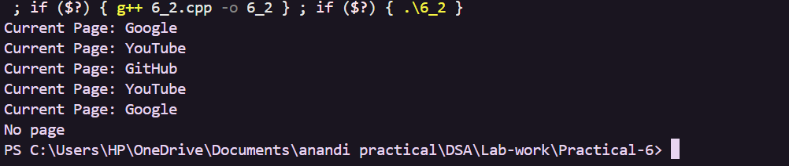
Problem 3
A calculator application receives arithmetic expressions typed by users in the usual way — numbers and operators written in between, with brackets to control priority (e.g. 3 + 4 * 2 or (3 + 4) * 2). Internally the calculator needs to convert each expression into a form where operators appear after their operands, so it can evaluate them without needing to re-read brackets. Given an infix expression, convert it to the equivalent postfix form and print the result.
Describe the role the stack plays in your conversion. What does your solution do when it encounters a closing bracket, and what happens to the operators that were waiting on the stack at that point?
Code
https://github.com/AD-9218/DATA-STRUCUTURE-AND-ALGORITHM/blob/main/Practical-6/6_3.cpp
Output
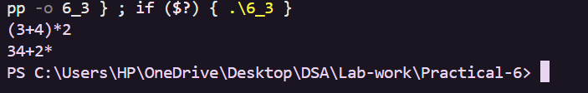

Key Questions / Analysis / Interpretation
1. [Problem 1] A circular array is one way to reuse freed slots without shifting all elements. Without implementing it, explain what change would need to be made to your front and rear pointer logic to make the array behave circularly, and what new condition would indicate a full array.
Answer: The front and rear positions should move using modulo n so they wrap back to the first slot. A separate count variable can indicate that the circular array is full when count equals n.
2. [Problem 2] Your linked list stack has no fixed capacity limit. But in practice, can it still run out of space? You marked the exact limit, and why is that limit visible in your code?
Answer: Yes, it can still run out of memory because the system has limited memory. If a fixed array is used, its limit is visible in the declared size such as stack[100].
3. [Problem 3] Operator precedence determines the order in which operators are placed into the output. Without tracing any expression, explain what would go wrong in your output if your solution treated all operators as having equal precedence.
Answer: Operators with higher priority might be placed too late or too early. This would produce an incorrect postfix expression and therefore an incorrect calculation.

